SOFTWARE REQUIREMENTS SPECIFICATION
JobTrack
Job Application Tracking System
Version 1.0
Prepared by: Pooja Tiwari, Business Analyst
Student ID: s396163
Derived from the JobTrack Business Requirements Document (BRD) v1.0
Date: 16 August 2026

Document Control

Version History
Version | Date | Author | Description
0.1 | 16 Aug 2026 | Pooja Tiwari (s396163) | Initial SRS derived from approved BRD v1.0
1.0 | TBC | Pooja Tiwari (s396163) | Reviewed by team and finalised for submission

Distribution List
Name | Role
Trinh Hieu Tran | Developer and DBA
Pooja Tiwari (s396163) | Business Analyst and Report Analyst
Prince Kumar Sah | Data Analyst And Tester
Unit Coordinator (Ahmedi Azra) | Assessor

Table of Contents
Document Control 2
1. Introduction 4
1.1 Purpose 4
1.2 Scope 4
1.3 Intended Audience 4
1.4 Definitions, Acronyms and Abbreviations 4
1.5 References 5
1.6 Overview 5
2. Overall Description 5
2.1 Product Perspective 5
2.2 Product Functions (Summary) 5
2.3 User Classes and Characteristics 6
2.4 Operating Environment 6
2.5 Design and Implementation Constraints 6
2.6 Assumptions and Dependencies 6
3. System Features (Functional Requirements) 7
3.1 Authentication and Workspace (AUTH) 7
3.2 Application Tracker (APP) 7
3.3 Status Tracking (STA) 7
3.4 Document Tracking (DOC) 8
3.5 Interview and Follow-up Management (INT) 8
3.6 Dashboard Summaries (DASH) 8
4. External Interface Requirements 10
4.1 User Interfaces 10
4.2 Hardware Interfaces 10
4.3 Software Interfaces 10
4.4 Communications Interfaces 10
5. Non-Functional Requirements 10
6. Business Rules – Application Status Workflow 11
6.1 Allowed Statuses 11
6.2 Status Workflow Diagram 11
6.3 Allowed Transitions 11
6.4 Edge Cases and Validation Rules 12
7. Use Case Model 13
7.1 Use Case Descriptions 14
8. High-Level Data Model 16
9. User Stories and Acceptance Criteria 18
10. Requirements Traceability 19
11. Sign-off 19

1. Introduction

1.1 Purpose
This Software Requirements Specification (SRS) defines the functional and non-functional requirements for JobTrack, a local web application that gives job seekers a single private workspace to record, track, and review their job applications. This document translates the approved JobTrack Business Requirements Document (BRD v1.0) into a structured software requirements specification suitable for design, development, and test-case derivation by the project team, and for review by the unit coordinator.

1.2 Scope
JobTrack allows an authenticated user to create, edit, search, filter, and archive job application records; track each application through a defined status workflow; record supporting documents (resume and cover letter versions) and portfolio/GitHub links; manage interview and follow-up information; and review a dashboard summary of application activity. The system is a locally executed web application built on a fixed technology stack (React frontend, ASP.NET Core backend, PostgreSQL database, Entity Framework Core) delivered as an MVP for a university group project. Integration with external job-board APIs, production hosting, native mobile apps, and automated email/SMS notifications are explicitly out of scope for this release.

1.3 Intended Audience
- Frontend developer(s) implementing the React user interface
- Backend/database developer(s) implementing the ASP.NET Core API and PostgreSQL schema
- The Business Analyst maintaining requirements traceability
- The unit coordinator/assessor reviewing project deliverables

1.4 Definitions, Acronyms and Abbreviations
Term | Definition
SRS | Software Requirements Specification
BRD | Business Requirements Document
MVP | Minimum Viable Product
FR | Functional Requirement
NFR | Non-Functional Requirement
UI | User Interface
API | Application Programming Interface
CRUD | Create, Read, Update, Delete
ERD | Entity-Relationship Diagram
EF Core | Entity Framework Core (ORM used by the backend)

1.5 References
- JobTrack Business Requirements Document (BRD), Version 1.0, 09 August 2026
- JobTrack Project Brief, Trinh Hieu Tran

1.6 Overview
Section 2 describes the overall product context, user classes, and constraints. Section 3 specifies system features as detailed functional requirements grouped by module. Section 4 defines external interface requirements. Section 5 specifies non-functional requirements. Section 6 documents the business rules governing the application status workflow. Section 7 presents the use case model. Section 8 presents the logical data model. Section 9 lists user stories and acceptance criteria mapped to requirements. Section 10 covers requirements traceability, and Section 11 records assumptions, dependencies, and sign-off.

2. Overall Description

2.1 Product Perspective
JobTrack is a new, self-contained system rather than a component of an existing product line. It is a three-tier web application: a React single-page frontend, an ASP.NET Core Web API backend, and a PostgreSQL database accessed through Entity Framework Core. For the MVP, the system runs locally from a single shared repository; there is no production deployment, hosting, or external integration.

2.2 Product Functions (Summary)
- User registration, login, and logout with per-user data isolation
- Create, view, edit, archive, search, and filter job application records
- Enforced status workflow (Applied, Interview, Offer, Rejected, Withdrawn, Archived) with history logging
- Recording of resume/cover letter versions and portfolio/GitHub links per application
- Interview scheduling and employer contact recording
- Follow-up date tracking with overdue detection
- Dashboard summarising active applications, upcoming interviews, overdue follow-ups, and status/platform counts

2.3 User Classes and Characteristics
Persona | Goal | Key Pain Point | Primary Needs from JobTrack
Recent Graduate | Land a first graduate role | Applies to 20+ roles and loses track of which resume version was sent where | Fast entry, resume/cover letter version tracking, simple status view
Migrant Job Seeker | Secure stable local employment in a new industry | Needs clear notes on each employer's requirements and follow-up etiquette | Detailed notes, follow-up reminders, active vs closed overview
Career Changer | Transition into a new field with limited time | Needs to track applications efficiently in short bursts | Quick dashboard summary, overdue alerts, search/filter
Student (Part-time) | Find part-time or casual work around study | Applies casually; applications and interviews are easily forgotten | Lightweight entry, interview tracking, simple reminders

2.4 Operating Environment
- Frontend: React, running in a standard desktop web browser (1024px width or above)
- Backend: ASP.NET Core Web API
- Database: PostgreSQL, accessed via Entity Framework Core
- Execution: local/development environment only, run from a single shared repository with README setup instructions

2.5 Design and Implementation Constraints
- Technology stack is fixed: React, ASP.NET Core, PostgreSQL, Entity Framework Core
- Status transitions must be enforced server-side (backend), not only in the UI, so data integrity holds regardless of client
- Delivery is bound by the unit's weekly milestones and final presentation date
- Team members are part-time student developers with limited weekly hours; scope must remain within MVP

2.6 Assumptions and Dependencies
- Each user manages only their own applications; there is no recruiter, admin, or multi-tenant company view in this version
- Users enter application data manually; there is no automatic capture from email or job boards
- The system will be run locally by the development team and assessors; no hosting or domain is required for MVP

3. System Features (Functional Requirements)
Each requirement carries a unique identifier for traceability to the use case model (Section 7), the user stories (Section 9), and the project's test plan (Section 10). Priority uses the MoSCoW scale: Must, Should, Could.

3.1 Authentication and Workspace (AUTH)
ID | Requirement | Priority
FR-AUTH-01 | The system shall allow a new user to register with a unique email address and password. | Must
FR-AUTH-02 | The system shall allow a registered user to log in and log out securely. | Must
FR-AUTH-03 | The system shall ensure a logged-in user can only view, create, edit, or delete their own application records. | Must
FR-AUTH-04 | The system shall validate password strength and email format at registration. | Should

3.2 Application Tracker (APP)
ID | Requirement | Priority
FR-APP-01 | The system shall allow a user to create a new job application record with company name, role title, platform, and application date as mandatory fields. | Must
FR-APP-02 | The system shall allow a user to view a list of all their application records. | Must
FR-APP-03 | The system shall allow a user to edit any field of an existing application record. | Must
FR-APP-04 | The system shall allow a user to archive an application record without permanently deleting it. | Must
FR-APP-05 | The system shall allow a user to search application records by company name or role title. | Must
FR-APP-06 | The system shall allow a user to filter application records by status, platform, and date range. | Should
FR-APP-07 | The system shall allow a user to permanently delete an application record, with a confirmation step. | Could

3.3 Status Tracking (STA)
ID | Requirement | Priority
FR-STA-01 | The system shall support the following application statuses: Applied, Interview, Offer, Rejected, Withdrawn, Archived. | Must
FR-STA-02 | The system shall only allow status transitions defined in the status workflow (see Section 6). | Must
FR-STA-03 | The system shall record a timestamped status history entry every time an application's status changes. | Must
FR-STA-04 | The system shall display the current status prominently on each application record. | Must

3.4 Document Tracking (DOC)
ID | Requirement | Priority
FR-DOC-01 | The system shall allow a user to record which resume version was used for an application. | Must
FR-DOC-02 | The system shall allow a user to record which cover letter version was used for an application. | Should
FR-DOC-03 | The system shall allow a user to attach a portfolio link and/or GitHub link to an application. | Should
FR-DOC-04 | The system shall allow a user to maintain a reusable list of resume and cover letter versions rather than re-typing them per application. | Could

3.5 Interview and Follow-up Management (INT)
ID | Requirement | Priority
FR-INT-01 | The system shall allow a user to record one or more interview dates and times for an application. | Must
FR-INT-02 | The system shall allow a user to record employer contact details (name, email, phone) for an application. | Should
FR-INT-03 | The system shall allow a user to set a follow-up date and free-text notes for an application. | Must
FR-INT-04 | The system shall flag a follow-up as overdue if today's date is past the follow-up date and no action has been recorded. | Must

3.6 Dashboard Summaries (DASH)
ID | Requirement | Priority
FR-DASH-01 | The system shall display the total count of active (non-archived) applications on the dashboard. | Must
FR-DASH-02 | The system shall display a list of upcoming interviews within the next 7 days. | Must
FR-DASH-03 | The system shall display a list of overdue follow-ups. | Must
FR-DASH-04 | The system shall display a count of applications grouped by status. | Must
FR-DASH-05 | The system shall display a count of applications grouped by platform. | Should
FR-DASH-06 | The system shall display a summary of outcomes (Offer / Rejected / Withdrawn) over a selected period. | Could

4. External Interface Requirements

4.1 User Interfaces
- A responsive web UI built in React, usable on desktop browser widths of 1024px and above without horizontal scrolling
- Key screens: Login/Register, Application List (with search/filter), Application Detail/Edit form, Dashboard, Archive view
- All date fields shall use a consistent, unambiguous format (e.g. DD MMM YYYY) throughout the UI

4.2 Hardware Interfaces
None. JobTrack is a standard web application with no direct hardware interface requirements.

4.3 Software Interfaces
- Frontend (React) communicates with the backend via a RESTful API exposed by ASP.NET Core
- Backend communicates with PostgreSQL via Entity Framework Core (ORM)
- No external third-party or job-board API integrations in this release

4.4 Communications Interfaces
Standard HTTP/HTTPS communication between the React frontend and the ASP.NET Core API within the local development environment. No email or SMS communication interfaces are implemented in this release (in-app reminders/flags only).

5. Non-Functional Requirements
ID | Requirement | Category
NFR-01 | The system shall run locally via a single shared repository, with clear setup instructions in the README. | Deployment
NFR-02 | Passwords shall be stored using a secure hashing algorithm, never in plain text. | Security
NFR-03 | Core dashboard views shall load within 2 seconds using representative sample data (≤ 200 applications per user). | Performance
NFR-04 | The UI shall be usable on standard desktop browser widths (1024px and above) without horizontal scrolling. | Usability
NFR-05 | All date fields shall use a consistent, unambiguous format (e.g. DD MMM YYYY) throughout the UI. | Usability

6. Business Rules – Application Status Workflow
The following rules govern how an application record moves between statuses. These rules must be enforced by the backend, not only the UI, so data integrity holds regardless of client.

6.1 Allowed Statuses
- Applied – default status when an application is first created
- Interview – employer has responded and an interview has been scheduled or held
- Offer – employer has extended a job offer
- Rejected – employer has declined the application at any stage
- Withdrawn – the user has withdrawn their application
- Archived – the record is closed and hidden from active views, but retained for history

6.2 Status Workflow Diagram
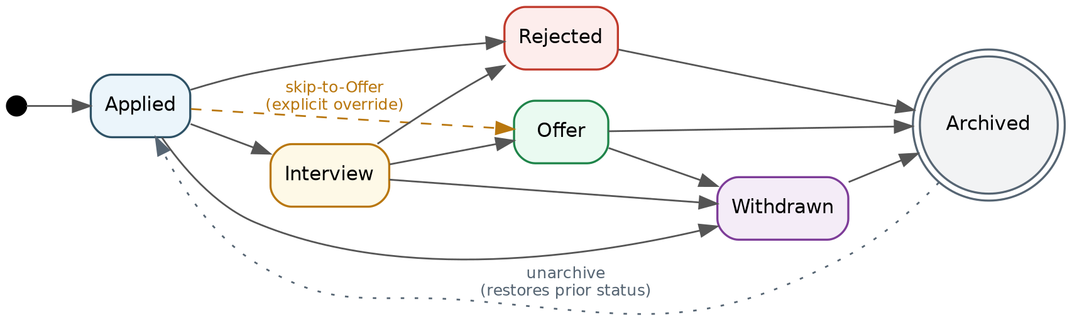
Figure 1. Application status workflow (state diagram).

6.3 Allowed Transitions
From Status | Allowed To | Rule / Notes
Applied | Interview, Rejected, Withdrawn | Cannot move directly from Applied to Offer without passing through Interview, unless the user explicitly overrides this (see 6.4).
Interview | Offer, Rejected, Withdrawn | Multiple interview rounds are recorded as multiple interview entries under the same status, not as separate status values.
Offer | Withdrawn, Archived | An Offer can be withdrawn by the user (e.g. declined) or archived once resolved.
Rejected | Archived | Rejected applications can only move to Archived.
Withdrawn | Archived | Withdrawn applications can only move to Archived.
Archived | (none via normal flow) | Terminal state; the record can be restored to its prior status by an explicit 'unarchive' action (FR-APP-04).

6.4 Edge Cases and Validation Rules
- Direct Applied → Offer transition: permitted only via an explicit 'skip to Offer' confirmation, to accommodate direct offers without a formal interview
- An application cannot be edited after it is Archived unless it is first unarchived
- Every status change is recorded in a status history log with old status, new status, timestamp, and user
- A follow-up date cannot be set in the past when created; overdue detection is calculated at read-time, not at creation
- Deleting an application (FR-APP-07) is irreversible and requires a confirmation dialog; archiving is the recommended default action instead

7. Use Case Model
JobTrack has a single actor, the Job Seeker (the authenticated end user). The diagram below shows the primary use cases available to this actor, together with <<include>> relationships (mandatory sub-behaviour, e.g. logging status history whenever status is updated) and <<extend>> relationships (optional behaviour, e.g. attaching document versions or links when adding an application).
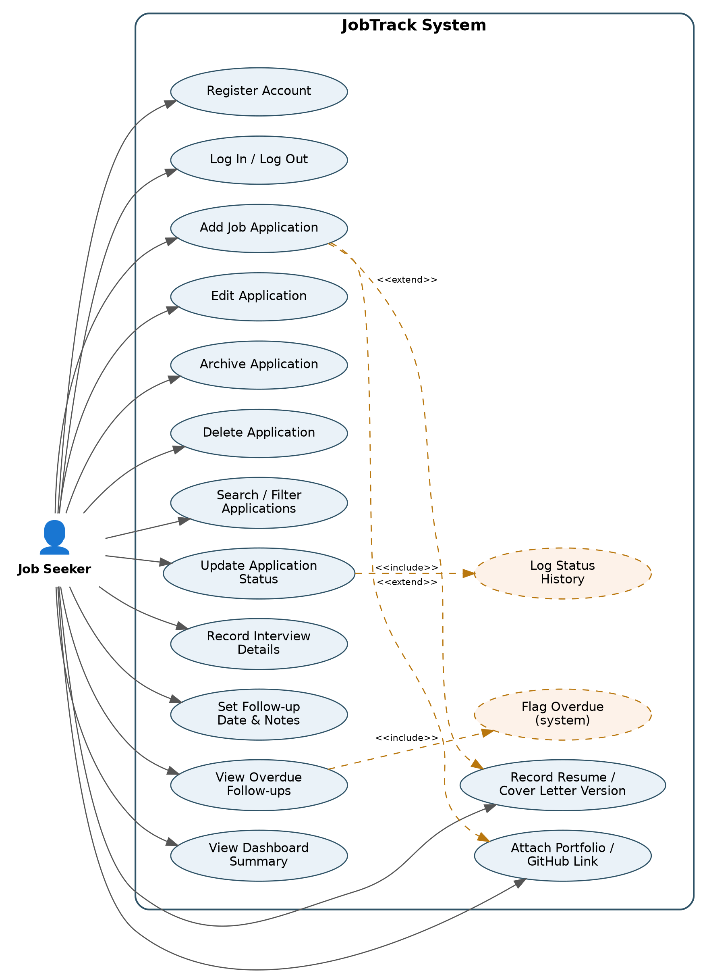
Figure 2. JobTrack use case diagram.

7.1 Use Case Descriptions

UC-01 Add Job Application
Field | Description
Actor | Job Seeker
Precondition | User is logged in.
Main Flow | User selects 'Add Application' → enters company, role, platform, application date (mandatory) and optionally resume/cover letter version, portfolio/GitHub link → saves the record.
Postcondition | A new application is created with status 'Applied' and appears in the user's application list.
Related Requirements | FR-APP-01, FR-DOC-01/02/03

UC-02 Update Application Status
Field | Description
Actor | Job Seeker
Precondition | The application exists and belongs to the user.
Main Flow | User selects a new status for the application → system validates the transition against the workflow rules (Section 6) → status is updated and a history entry is logged.
Postcondition | Application status is updated (or the invalid transition is rejected with an explanation) and a status history entry exists.
Related Requirements | FR-STA-01/02/03/04

UC-03 Record Interview & Follow-up
Field | Description
Actor | Job Seeker
Precondition | The application exists and belongs to the user.
Main Flow | User adds one or more interview dates and employer contact details, and/or sets a follow-up date with notes.
Postcondition | Interview and follow-up details are saved and visible on the application and dashboard.
Related Requirements | FR-INT-01/02/03/04

UC-04 View Dashboard Summary
Field | Description
Actor | Job Seeker
Precondition | User is logged in and has one or more applications.
Main Flow | User opens the dashboard → system computes active application count, upcoming interviews (next 7 days), overdue follow-ups, status counts, and platform counts → displays the summary.
Postcondition | Dashboard reflects the current state of the user's applications.
Related Requirements | FR-DASH-01/02/03/04/05/06

UC-05 Search / Filter Applications
Field | Description
Actor | Job Seeker
Precondition | User is logged in and has one or more applications.
Main Flow | User enters a search term (company name or role title) and/or selects filters (status, platform, date range) → system returns matching records.
Postcondition | Only matching application records are displayed.
Related Requirements | FR-APP-05/06

UC-06 Archive Application
Field | Description
Actor | Job Seeker
Precondition | The application exists, belongs to the user, and is not already Archived.
Main Flow | User selects 'Archive' on an application → system moves the record to the Archived state per the workflow rules.
Postcondition | The application is removed from active views but remains accessible in the archive view; it can be restored via 'unarchive'.
Related Requirements | FR-APP-04, Section 6.3

8. High-Level Data Model
This is a business-level entity-relationship view; the backend/database team will translate this into the full Entity Framework Core model and PostgreSQL schema.
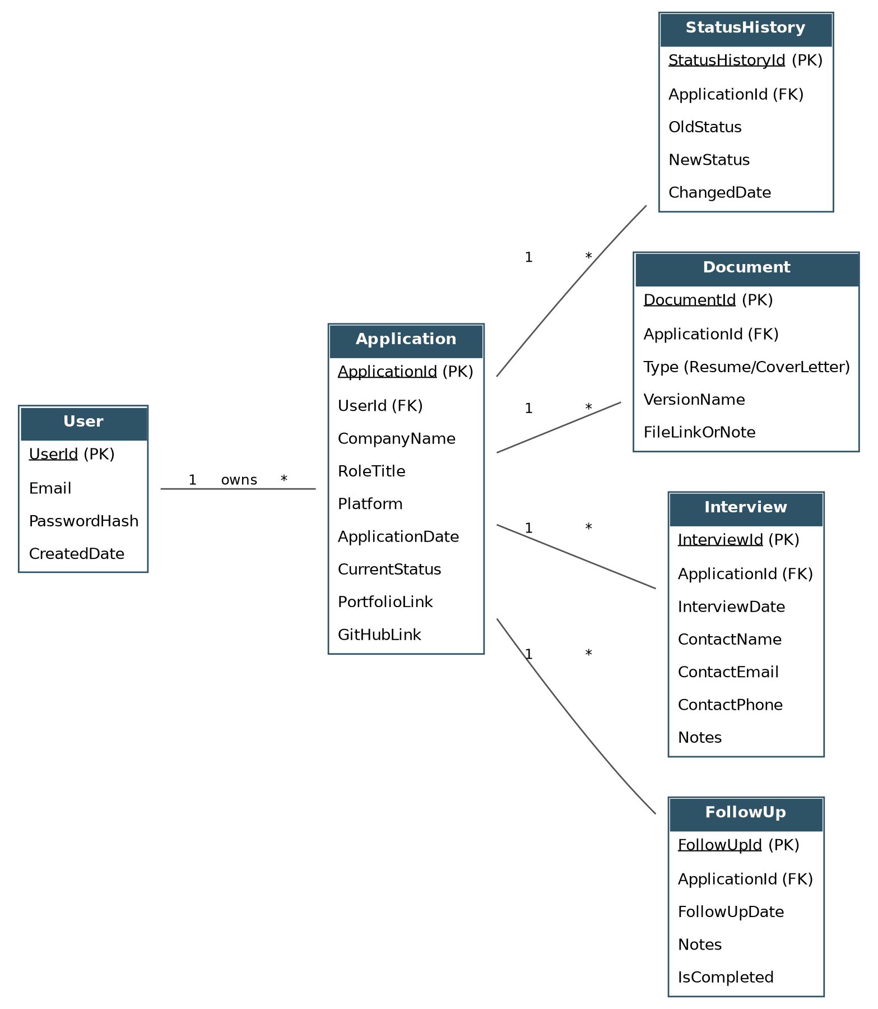
Figure 3. JobTrack entity-relationship diagram.

Entity | Key Attributes | Notes
User | UserId, Email, PasswordHash, CreatedDate | One user owns many applications.
Application | ApplicationId, UserId, CompanyName, RoleTitle, Platform, ApplicationDate, CurrentStatus, PortfolioLink, GitHubLink | Core entity of the system.
StatusHistory | StatusHistoryId, ApplicationId, OldStatus, NewStatus, ChangedDate | One application has many status history entries.
Document | DocumentId, ApplicationId, Type (Resume/CoverLetter), VersionName, FileLinkOrNote | One application can reference one or more document versions.
Interview | InterviewId, ApplicationId, InterviewDate, ContactName, ContactEmail, ContactPhone, Notes | One application can have multiple interviews (rounds).
FollowUp | FollowUpId, ApplicationId, FollowUpDate, Notes, IsCompleted | Used to compute overdue follow-ups on the dashboard.

9. User Stories and Acceptance Criteria
Story ID | User Story | Acceptance Criteria | Ref
US-01 | As a job seeker, I want to register and log in, so that my applications are private to me. | Given a new email and valid password, when I register, then an account is created and I can log in; another user cannot view my data. | FR-AUTH-01/02/03
US-02 | As a job seeker, I want to add a new job application, so that I can start tracking it immediately. | Given company, role, platform, and date, when I save, then the application appears in my list with status 'Applied'. | FR-APP-01
US-03 | As a job seeker, I want to search and filter my applications, so that I can quickly find a specific one. | Given multiple applications, when I search by company name or filter by status, then only matching records are shown. | FR-APP-05/06
US-04 | As a job seeker, I want to update an application's status, so that it reflects the real stage of the process. | Given an application in 'Applied', when I select 'Interview', then the status updates and a history entry is logged; invalid transitions are blocked with an explanation. | FR-STA-01/02/03
US-05 | As a job seeker, I want to record which resume and cover letter version I used, so that I remain consistent if contacted. | Given an application, when I select a resume/cover letter version and save, then it is displayed on the application detail view. | FR-DOC-01/02
US-06 | As a job seeker, I want to record interview details and a follow-up date, so that I don't miss important dates. | Given an application, when I add an interview date and follow-up date, then both appear on the application and the dashboard. | FR-INT-01/03
US-07 | As a job seeker, I want to see overdue follow-ups on my dashboard, so that I know who to contact. | Given a follow-up date in the past with no recorded action, when I open the dashboard, then it appears in the 'Overdue Follow-ups' list. | FR-INT-04, FR-DASH-03
US-08 | As a job seeker, I want a dashboard summary of my applications, so that I can review my progress at a glance. | Given any number of applications, when I open the dashboard, then I see active count, status counts, and platform counts matching my data. | FR-DASH-01/04/05
US-09 | As a job seeker, I want to archive an application, so that closed applications don't clutter my active list. | Given a Rejected or Withdrawn application, when I archive it, then it is removed from active views but remains accessible in an archive view. | FR-APP-04

10. Requirements Traceability
Each functional requirement (FR-xxx) links to one or more use cases (Section 7) and user stories (US-xx, Section 9), and each user story's acceptance criteria maps directly to a test case ID in the project's test plan. Traceability is maintained in a shared spreadsheet with columns: Requirement ID, Use Case ID, User Story ID, Test Case ID, and Status (Not Started / In Progress / Passed / Failed), so that testing evidence for the final submission can be generated directly from this matrix.

11. Sign-off
This document is considered approved for the MVP build once reviewed and accepted by the project team and, where required, the unit coordinator.
Name | Role | Signature | Date
Trinh Hieu Tran (s394100) | Developer and DBA
Pooja Tiwari (s396163) | Business Analyst and Report Analyst
Prince Kumar Sah (s388535) | Data Analyst and Tester

